Amruthesh - 241059041

Cybersecuirty  MSIS

Juiceshop lab internals

**Pull JuiceShop through Docker**

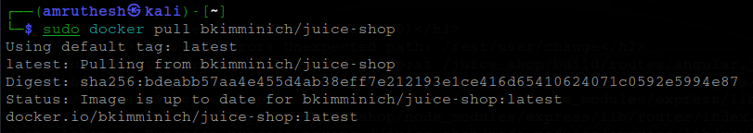

**Run the JuiceShop**

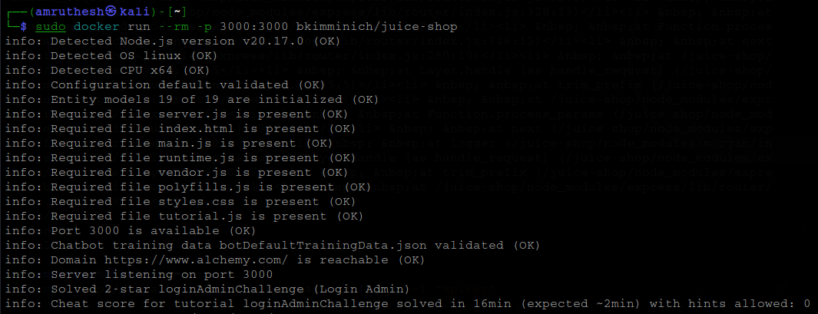

**Open it in the Browser**

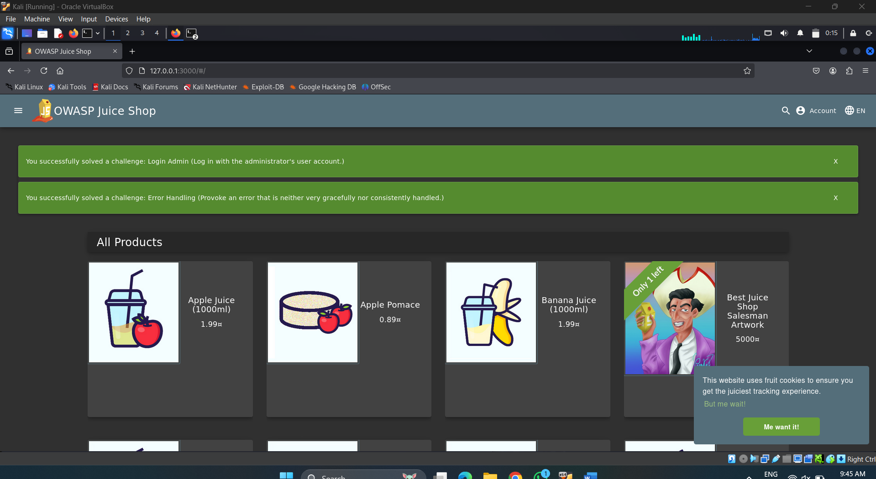

**Information Gathering (Reconnaissance) on Juice Shop**

**Banner Grabbing**

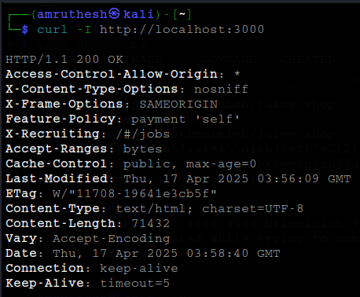

**Directory and File Enumeration**

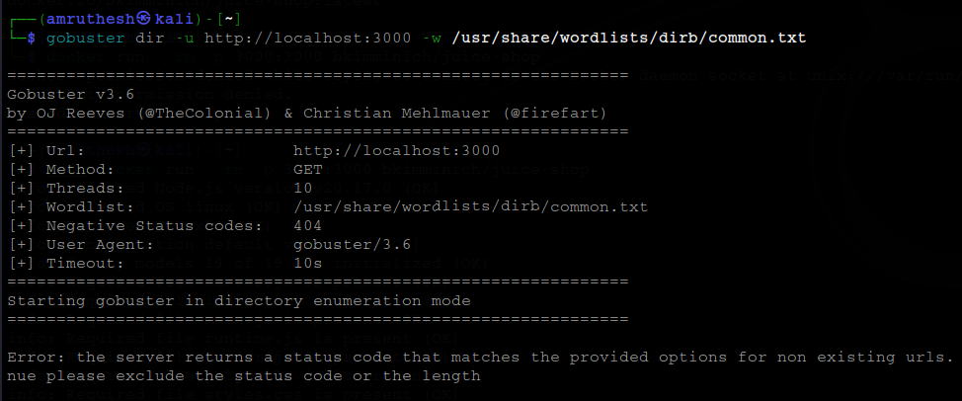

**Identify Technologies Used**

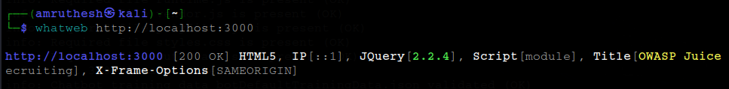

**Vulnerability Scan (using Nmap scripts):**

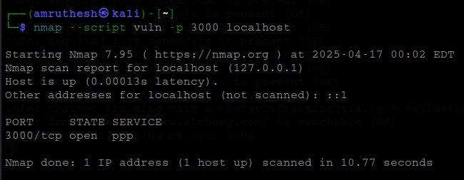

**Gather info from inspect element**

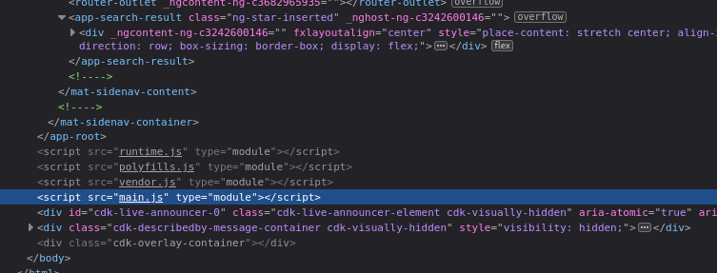

**Web Server Vulnerabilities in Juice Shop  
Cross-Site Scripting (XSS)**

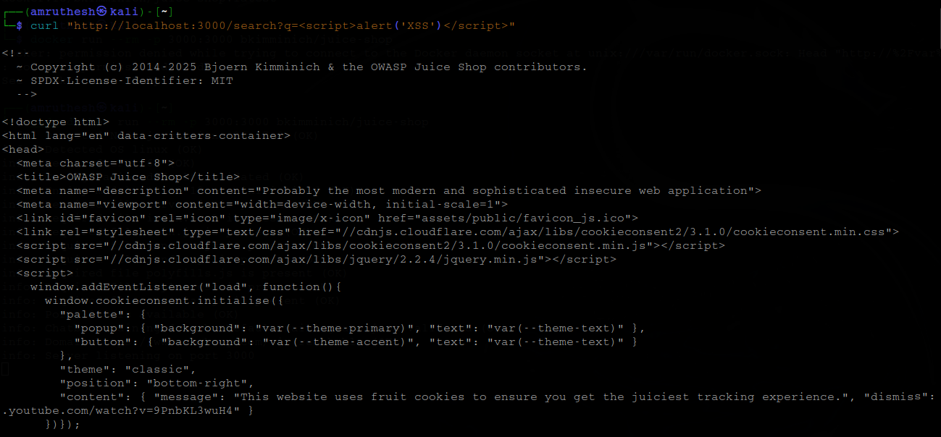

**Cross-Site Request Forgery (CSRF)**

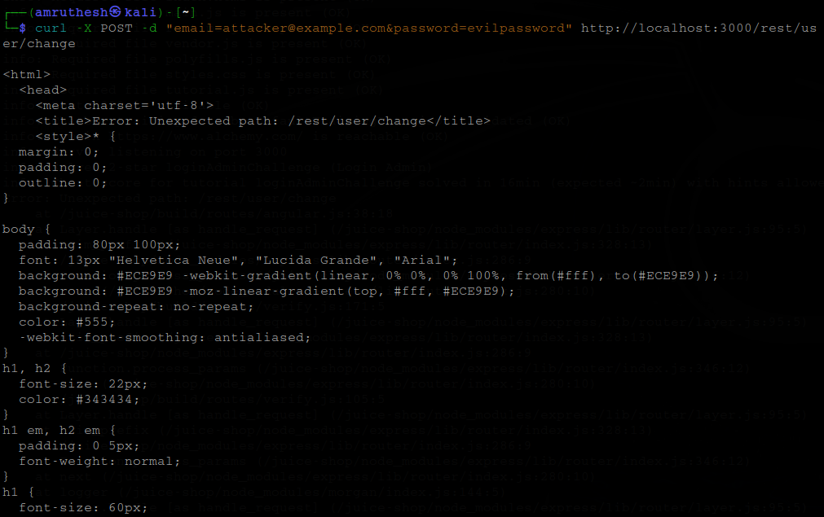

**Sensitive Information in URLs or JavaScript Files**

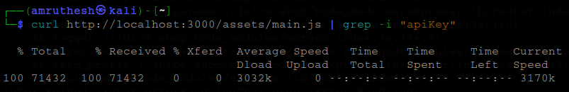

**SQL Injection (SQLi)**

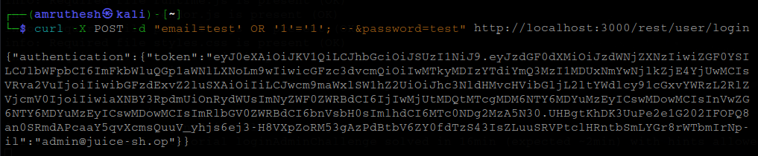

**Easily Accessible JS/Config files**

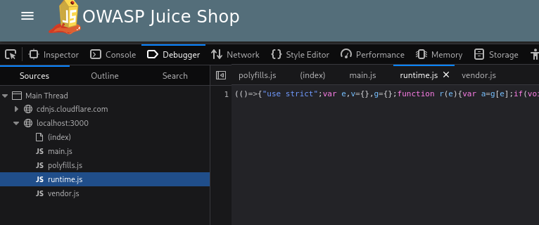

**Exploits / Payloads on Juice Shop**

**SQL Injection (Login Bypass)**

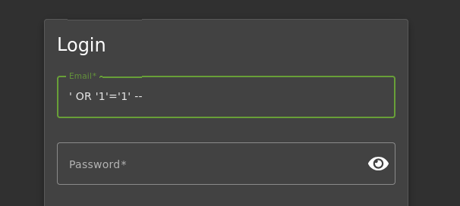

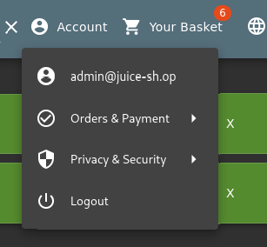

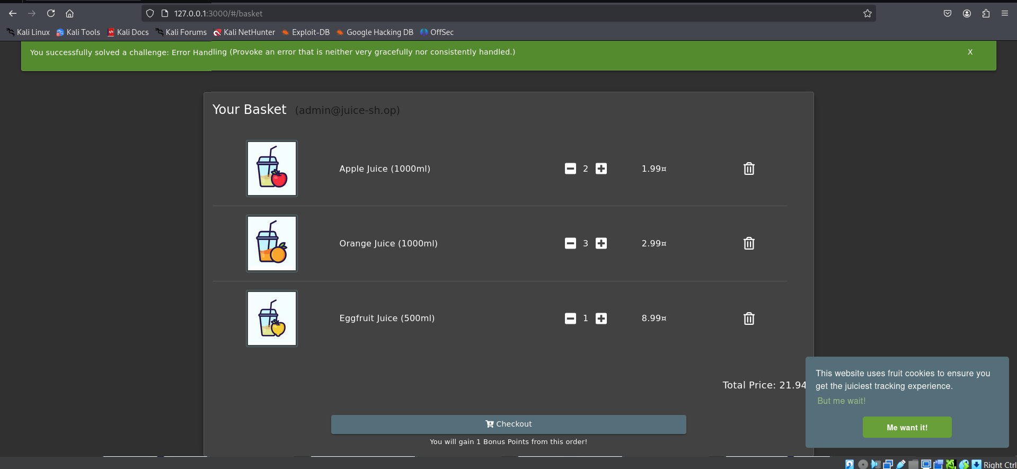

**Reflected XSS in Search Bar**

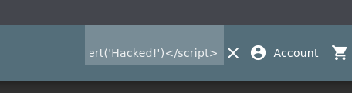

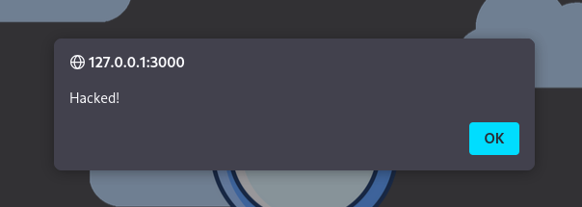

**Try Different Variations of XSS Payloads**



**Exploiting Insecure File Upload**

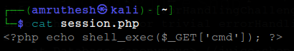

**Simple Redirect Link**

